Heparin Oligosaccharide

Catalogue no: HO16
Designation: Heparin Saccharide Ammonium Salt. Average Mw. ~ 4650
The average value for Mw. takes account of the contribution of the ammonium counterion.
General Description: These oligosaccharides have been prepared by high resolution gel filtration of partial heparin lyase digestion of high quality heparin.
General formula*
∆HexA,2S - GlcNS,6S– (IdoUA,2S – GlcNS,6S)_{n}
_{n} = number of disaccharide units.
*Although the main disaccharide unit in these products is IdoUA,2S – GlcNS,6S, (approx 75%) saccharides in each size class show some variation in degree and pattern of sulphation.
Uronic acid (HexA) at the non-reducing end of the oligosaccharides has a C4-C5 double bond as a result of the endolytic action of bacterial heparin lyase.
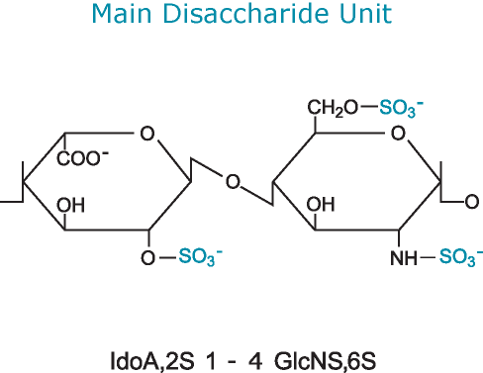

Quantity: 2mg per vial
Appearance: White/yellow powder
Origin: High Quality Heparin
Toxicity and Hazards: We are not aware of any toxicity associated with this product. In common with good laboratory practice the material should only be handled by qualified personnel trained in laboratory procedures and familiar with potential hazards.
These products are not intended for human consumption, drug use or any form of human experimentation.
Applications: Biological/biochemical laboratory research
Storage: We do recommend that all products are stored frozen at –15 to – 20 degrees Celsius upon receipt and that they are allowed to warm to room temperature before opening. If made up into solutions avoid repeated freeze-thawing. Stock solutions should be prepared in appropriate aliquots and stored frozen.

Warranties: Iduron warrants that its products shall conform to the description of such products as provided in Iduron’s catalogue. This warranty is exclusive, and seller makes no other warranty, expressed or implied, including any implied warranty of merchantability or fitness for any particular purpose. See ‘terms and conditions’ for further warranty Information.

