Hyaluronic Acid Oligosaccharide

Catalogue no: HA14
Designation: Disaccharide dp14.
General Description: These oligosaccharides have been prepared by high resolution gel filtration of partial endolyase digestion of purified Streptococcal HA. Very low in endotoxin
General formula*
∆HexAβ1,3 [GlcNAcβ1,4 GlcAβ1,3]_{n} GlcNAc
Uronic acid (HexA) at the non-reducing end of the oligosaccharides has a C4-C5 double bond as a result of the endolyase scission.
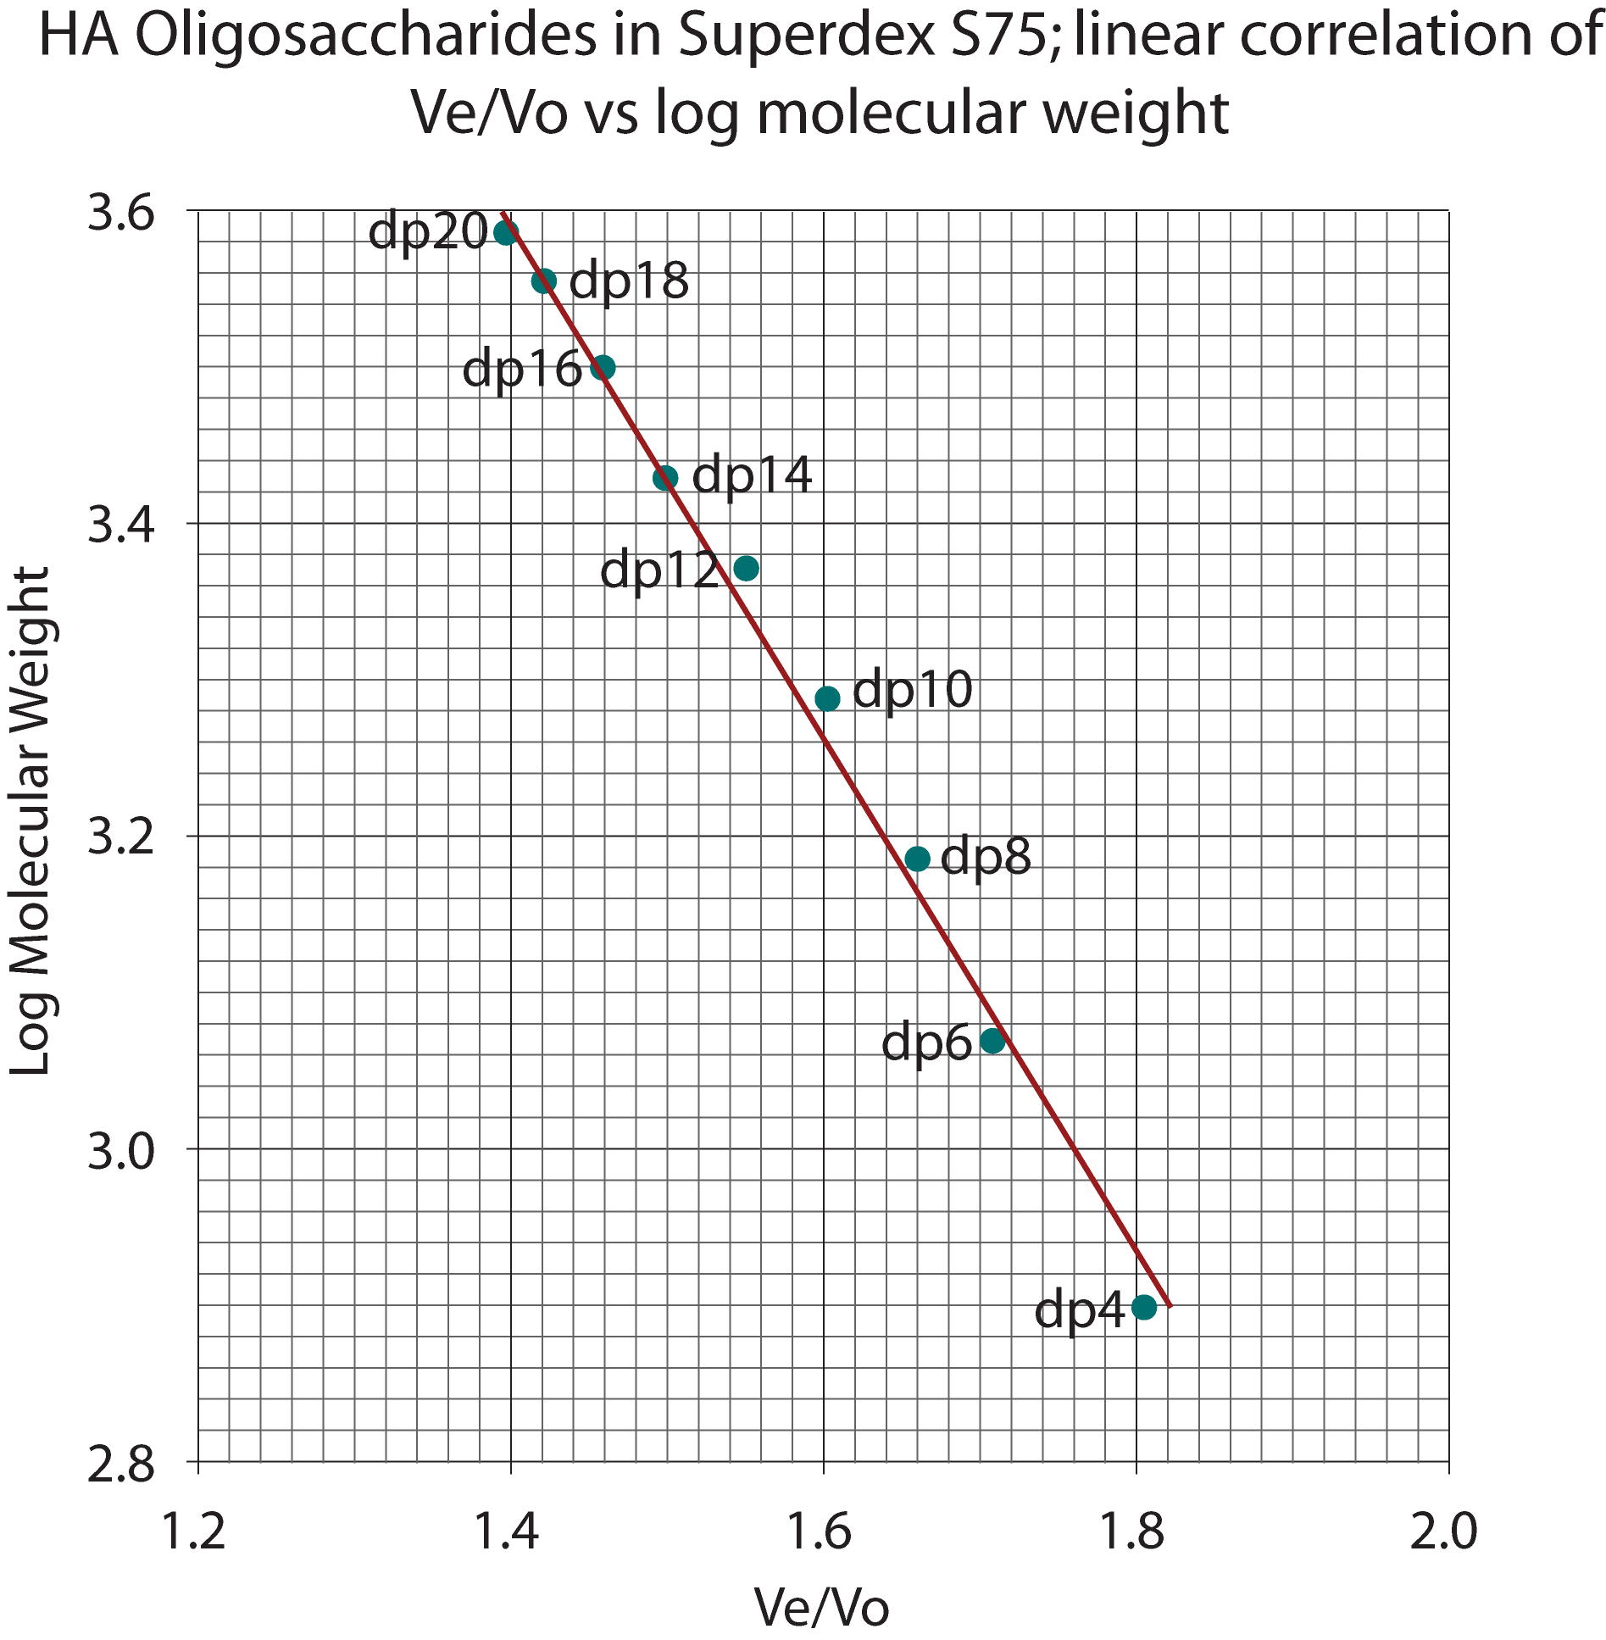
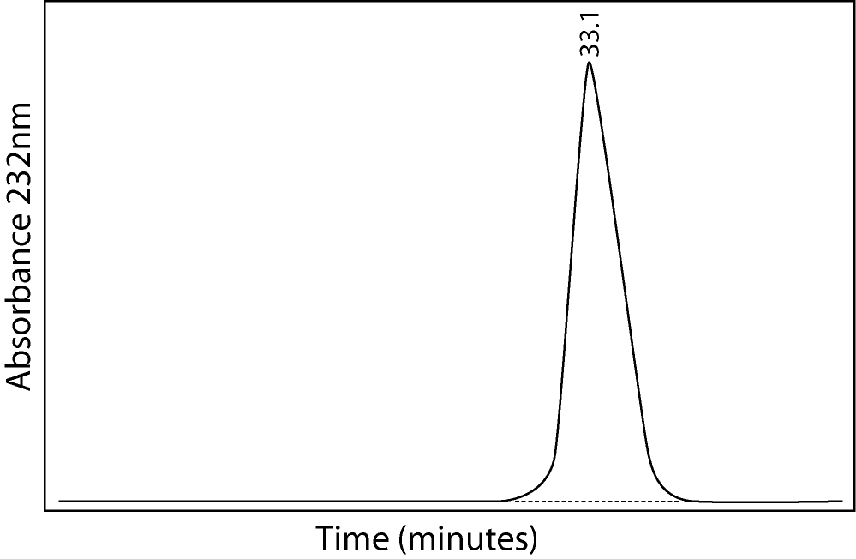

Quantity: 1mg per vial
Appearance: White/yellow powder
Origin: Purified Streptococcal Hyaluronic Acid. Very low endotoxin.
Toxicity and Hazards: We are not aware of any toxicity associated with this product. In common with good laboratory practice the material should only be handled by qualified personnel trained in laboratory procedures and familiar with potential hazards. These products are not intended for human consumption, drug use or any form of human experimentation.
Applications: Biological, biochemical and biophysical laboratory research
Storage: We recommend that all products are stored frozen at –15 to – 20 degrees Celsius upon receipt and that they are allowed to warm to room temperature before opening. If made up into solutions avoid repeated freeze-thawing. Stock solutions should be prepared in appropriate aliquots and stored frozen.

Warranties: Iduron warrants that its products shall conform to the description of such products as provided in Iduron’s catalogue. This warranty is exclusive, and seller makes no other warranty, expressed or implied, including any implied warranty of merchantability or fitness for any particular purpose. See ‘terms and conditions’ for further warranty information.

